HomeWork 18 Blockchain

• Create a new project directory for your new network. Call it whatever you want!

• Create a "Screenshots" folder inside of the project directory.

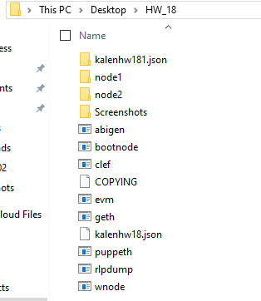

• Created accounts for two (or more) nodes for the network with a separate datadir for each using geth.

\* ./geth --datadir node1 account new

\* ./geth --datadir node2 account new



• Ran puppeth, named my network “kalenHW”, and selected the configure new genesis block. See screenshot part 1

• I choose Clique (Proof of Authority) consensus algorithm.

• Paste both of my account addresses from the first step one at a time into the list of accounts to seal. 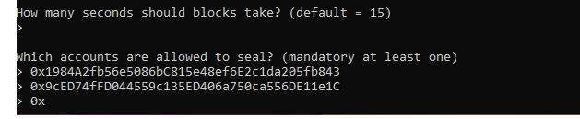

• Paste them again in the list of accounts to pre-fund. There are no block rewards in PoA, so you'll need to pre-fund. 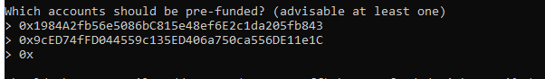

• You can choose no for pre-funding the pre-compiled accounts (0x1 .. 0xff) with wei. This keeps the genesis cleaner. 

• Complete the rest of the prompts, and when you are back at the main menu, choose the "Manage existing genesis" option. 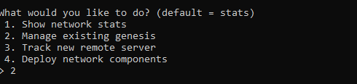

• Export genesis configurations. This will fail to create two of the files, but you only need networkname.json. 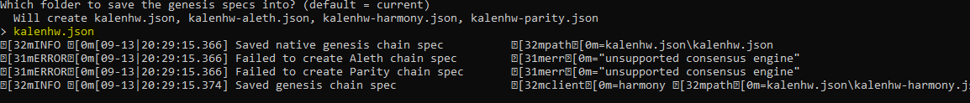

• I did delete the kalenhw-harmony.json file.

• Screenshot the puppeth configuration once complete and save it to the Screenshots folder.



• Initialize each node with the new kalenhw.json with geth.

